Name
Institutional affiliation
Course
Date

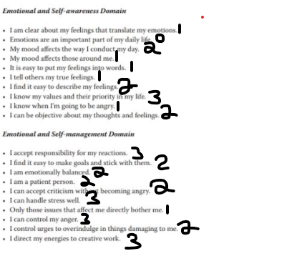
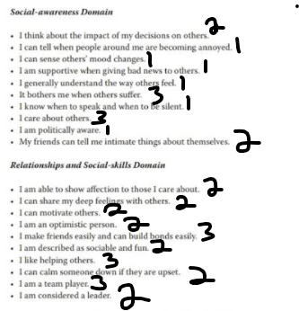

Emotional and self-awareness domain (total points 14)
Emotional and self-management domain (total points 23)
Social awareness domain (total points 16)
Relationships and social skills domain (total points 24)
After adding my points, I realized that my strongest domain is relationship and social skills domain while my weakest domain is Emotional and self-awareness domain. Looking at my strongest domain, relationship and social skills domain, I am able to participate and cooperate well in my group discussions we have formed in our class. I arrive in time at the venue of our discussion meetings, I also make sure that I participate well during the discussions by giving out my ideas and asking questions where I have not understood. I am also a group leader of various discussion groups and I ensure that every member arrives early for discussions, ensure they do the assigned tasks and also ensure that every member’s point during discussion is heard ad considered. Most people love when I lead them and they say that I am sociable ad fu to interact with as well as a good leader.
My weakest domain which is Emotional and self-awareness domain, makes me not to be realistic about my thoughts and my actions, I react very differently to actions at a given time and space. Sometimes I may get angry at someone for doing something to me while other times I may not be angry at the same action. Therefore, I cannot easily predict my feelings. I am also not open to telling people my true feeling especially when I am hurt. I may be going through depression but I decide to deal with it alone which is bad thing. My weakest domain affects those near me because when I am angry, they can’t tell what happened to me, sometimes it is hard for them to realize what actions will hurt me and what will make me happy. I have realized that I should let someone help me. when I talk to someone, they will be able to help me to heal first. also, I should learn that emotions affect our way of living as well as learning what makes angry and what makes me happy. That way I will be able to learn and let people help me understand my feelings.
I have leant that most people in my class are social, care about others, know their values ad priorities in their life, like helping others and are team players just like me. However, most people differ from me in that their emotions are very important to their life and they share their true feelings with their friends to get help. One of my group mates made me understand that certain feelings affect my emotions and I should be clear about them in order to understand my true emotions since they are important aspects in my life.

